**Observation**

Inspection was undertaken at the subject property in the presence of the Insured to which the following tree impact damage was noted:

1. We have provided **Figure 2** below, a schematic floor plan of the subject property, highlighting the areas and elements sustained tree impact damage.

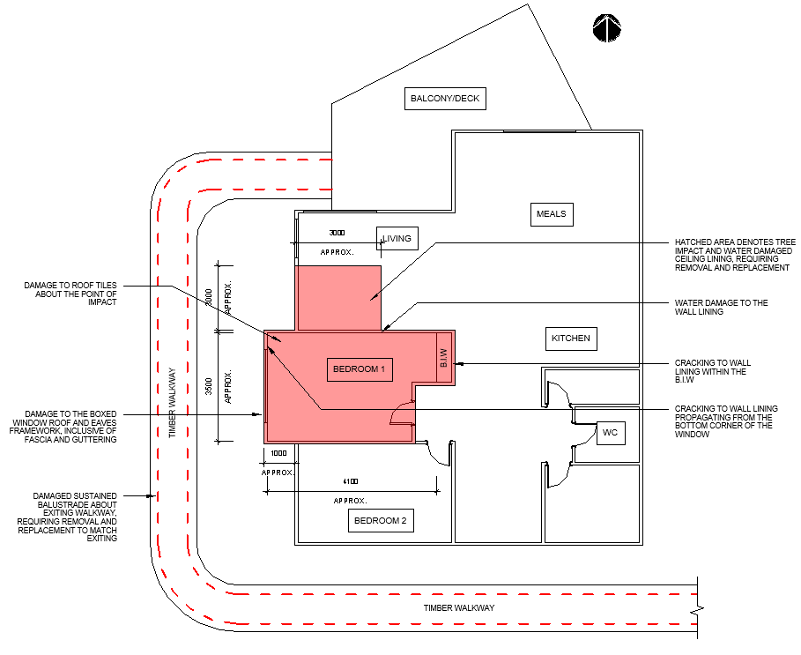

Figure 2- Schematic Plan of Subject Property

*Notes:*

* *Not to Scale.*
* *The provided dimensions are indicative only and to be confirmed on-site.*

## Extent of Tree Impact Damage - External Areas

### Damaged Roof Tiles and Roof Framework (Western Alignment)

1. We noted localised damage to the exiting roof ties corresponding to the direct point of tree impact, requiring removal and reinstatement to match exiting. Should match to existing be not feasible, provisional allowance to be provided for removal and replacement of the entire roof tiles within the western alignment to achieve a uniform look as much as practicable.
2. We noted damage to the roof sarking corresponding to the point of direct tree impact, which requires removal and replacement within the western alignment of the roof up to the roof ridge.
3. In saying that, the existing undamaged roof tiles within the western alignment of the roof are also warranting to be temporarily removed, stored and reinstated in facilitating the installation of a new sarking membrane.
4. We also noted localised damage to a number of roof rafters and battens over Bedroom 1, requiring removal and replacement in accordance with *AS 1684 – Residential Timber-Framed Construction*. **Image 2**
5. Given our limited view of the roof cavity, we were unable to identify the exact extent of damage to the roof framework.
6. However; from our inspection, no evidence of excessive deflection of movement to the eastern alignment of the roof was noted to suggest the integrity of the roof framework has been compromised.
7. As such, we recommend further investigation to be undertaken during the rectification works to assure the integrity of the roof framework has not been affected due to tree impact.
8. Moreover, we noted damage to the eaves gutter about the point of tree impact. As such, the entire eaves gutter along the western alignment of the roof requires removal and reinstatement to match the exiting profile and configuration in line with the relevant Australian Standards.

### Bedroom 1 Boxed Window

1. We inspected evidence of damage to the roof sheet and fascia board and eaves gutter along the Bedroom 1 boxed window, consistent with tree impact damage. **Images 3 & 4**
2. Consequently, the entire roof sheet together with the fascia board and eaves guttering to be removed and reinstated to match exiting.

### Damaged Western Alignment Eaves Lining

1. We noted evidence of damage to the eaves lining corresponding to the western elevation of the Living area, consistent with tree impact damage, requiring partial removal and reinstatement to match existing. **Image 4**
2. We also observed cracking to the eaves lining along the junction to the Boxed Window roof framework, consistent with impact damage, requiring removal and replacement, to match exiting.

### Damaged Walkway Balustrade

1. We further noted evidence of damage to the existing balustrade running along the timber walkway about the western side of the main residence. **Image 5**
2. In our opinion, the noted damage is consistent with subject tree impact damage and requires complete removal and reinstatement to match exiting.
3. In our opinion, the extent of damage is only limited to the balustrade and the overall integrity of the walkway structure has not been compromised.

### Subfloor

1. Further to the above, we undertook the inspection of the subfloor area. **Images** **6 & 7**
2. The existing flooring framing is consisting of timber joists and bearers supported off the isolated stumps.
3. From our inspection, no cracking, movement or distress to the flooring and stumps was noted suggesting the structural integrity of the sub-floor area has been compromised.

## Extent of Tree Impact Damage - Internal Areas

### Bedroom 1

1. Within Bedroom 1 we noted the following damage consistent with the subject tree impact damage:

**Images 8 – 14**

* 1. We noted evidence of damage to the ceiling, requiring removal and reinstatement to match existing.
  2. We noted damage to the ceiling framework, requiring removal and replacement to match existing.
  3. We noted water ingress damage to the wall lining corresponding to the northern side of the bedroom as a result of water permeating during the storm event.
  4. We further noted cracking to the wall lining propagating from the bottom left corner of the window opening, requiring patch and repair.
  5. We noted cracking to the wall lining along the ceiling junction within the B.I.W about the bedroom, consistent with damage due to vibration force induced by the subject tree impact event.

### Living Area

1. We observed localised damage to the ceiling lining with evidence of a tree branch punched through the lining corresponding to the southwest corner of the Living area. **Image 15**
2. We also note signs of water stain damage to the ceiling lining within the southwest corner of the Living area consistent with water ingress during the subject storm event. **Image 16**
3. As such, the damaged portion of the ceiling lining will warrant removal and reinstatement to match the existing. Refer to **Figure 2** for the approximate extent of the damage.

### Miscellaneous Damage Consistent with Tree Impact

1. We noted evidence of damage to the exiting satellite antenna/dish local to the direct point of impact, requiring removal and reinstatement. **Image 17**
2. Moreover, we noted damage to the exiting lights affixed within the eaves lining along the western alignment, requiring removal and reinstatement to match exiting.

**Discussion**

NA

**Conclusion**

Identified external and internal damage detailed within the body of this report is consistent with the experienced tree impact or subsequent water ingress damage during the storm event due to the compromised roof.

At the time of our inspection, we are unable to determine the extent of damage to the roof framework due to the enclosed raked ceiling configuration.

However, from our inspection, no evidence of excessive deflection of movement to the eastern alignment of the roof was noted to suggest the integrity of the roof framework has been compromised.

As such, we recommend further investigation to be undertaken during the rectification works to assure the integrity of the roof framework has not been affected due to tree impact.

In addition, we undertook the inspection of the subfloor area, to which no evidence of cracking, movement or distress to the flooring and stumps was noted suggesting the structural integrity of the sub-floor area has been compromised.

Considering the foregoing, in our opinion, the overall structural integrity of the building has not been compromised apart from the localised damage as identified within this Report, which can be repair and reinstated.